|  |  |
| --- | --- |
|  | **School of Engineering** |

|  |  |  |
| --- | --- | --- |
| **ELC333-L1** |  | **Spring 2020** |

**Lab 3**

**Introduction to Field-Effect Transistors**

**Date: 3/13/2020**

**Submitted by: Jeffrey Blanda, Alexander Bolen, Miguel Flores**

**Instructor: Joseph Jesson**

1. **Introduction (JB)**

**1.1 Objectives:**

* Become familiar with Field Effect Transistors and building circuits with them
* Design, construct, and test a switching circuit, voltage amplifier circuit, and a logic gate circuit using a FET.
* Characterize FET behavior under different conditions.
  1. **Importance:**

FETs are one of the most popular modern-day transistors and can be used to switch things on or off in a circuit. FETs can be used in other devices as well such as multiplexers, current limiters, and amplifiers.

* 1. **Theory:**

FETs are transistors of two types, n-type where a positive voltage will allow current to flow across the source to the drain terminal, while a negative voltage prevents this and p-type where the reverse is true, and a negative voltage will allow current to flow. The threshold voltage is the voltage that for an n-type MOSFET that attracts bound negative charges to the depletion region and allows current to flow. In this lab we used an enhancement mode (n-type) MOSFET.

1. **Materials and Devices (JB)**

* 2N7000, n-Channel Enhancement-Type MOSFET
* 2N7000 Datasheet
* LT03XX-41 Red LED
* 200Ω Resistor
* Breadboard
* VirtualBench (Oscilloscope/Multimeter/Power Supply)

1. **Procedure (MF, JB, AB)**

**3.1 MOSFET Characterization via PSpice:**

**Step 1:** Acquire 2N7000 Metal-Oxide Field-Effect Transistor (MOSFET) from the parts cabinet.

**Step 2:** Read about MOSFETs in chapter #5 of Sedra text. What is the difference between triode and saturation regions of operation? What is vOV? Also, in a general sense, what is the difference between operation of n-channel and p-channel MOSFETs (e.g. how vGS affects iD)?  
The triode region of the MOSFET is the region the current gain isn’t constant, and it depends on the voltage. The saturation region is where the voltage no longer matters and the current gain is relatively constant. Vov is known as the effective voltage, or the voltage needed to activate the FET. Lastly, p-channel MOSFETs use a negative gate voltage to activate the FET while n-channel MOSFETs use a positive gate voltage to activate the FET.

**Step 3:** Design a circuit in PSpice (like that shown in Figure 3) that allows observation of the MOSFET voltage-current characteristic. This requires the use of two separate DC voltage supplies and a current probe. Note both the exact transistor model to use as well as its orientation.

**Step 4:** In the report, include a screenshot of YOUR PSpice schematic.

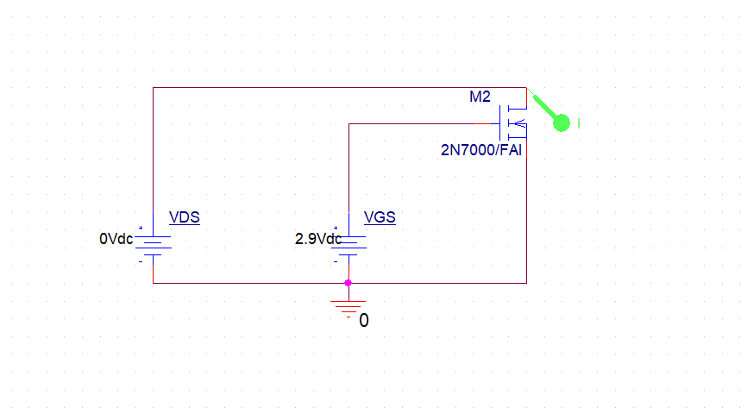

Figure 1: Basic 2N7000 MOSFET test circuit in Cadence PSpice.

**Step 5:** Open a new simulation profile using the button in the top-left corner of the screen. Provide an appropriate simulation name.

**Step 6:** Set vGS = 3.0V, for now. Simulate the response of this circuit to DC sweep from vDS = 0V to 15V with increment of 0.1V.

**Step 7:** Copy this data to Microsoft Excel.

**Step 8:** Repeat the simulation performed in Step #6 with vGS=2.60V, 2.70V, 2.80V, and 2.90V. In the lab report, include a single iD vs. vDS plot with five traces (corresponding to different levels of vGS).

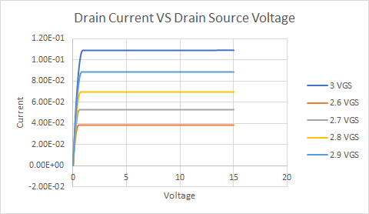

Figure 2: Drain Current vs. Drain Source Voltage containing 5 different plots from 5 different vGS values.

**3.2 Lab Characterization of a Device**

**Step 9:** Build the circuit shown in Figure 3, using the n-channel MOSFET.

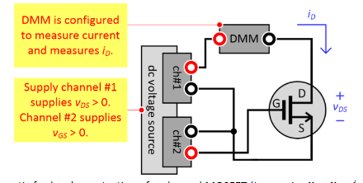

Figure 3: Schematic for hardware testing of n-channel MOSFET

**Step 10a:** Complete the table below by taking measurements of values of ID shown in Table 1, below.

|  |  |  |  |
| --- | --- | --- | --- |
|  | $v_{GS}$**=2.4V** | $v_{GS}$**=2.5V** | $v_{GS}$**=2.6V** |
| $v_{DS}$**(V)** | $i_{D}$**(mA)** | $i_{D}$**(mA)** | $i_{D}$**(mA)** |
| 0.0 | 0.0 | 0.0 | 0.0 |
| 0.2 | 3.89 | 6.72 | 10.55 |
| 0.4 | 4.41 | 7.96 | 13.33 |
| 0.6 | 4.454 | 8.27 | 14.00 |
| 0.8 | 4.426 | 8.27 | 14.4 |
| 1.0 | 4.404 | 8.25 | 14.8 |
| 1.2 | 4.38 | 8.34 | 15.3 |
| 1.4 | 4.37 | 8.30 | 15.8 |
| 1.6 | 4.356 | 8.31 | 16.3 |
| 1.8 | 4.386 | 8.33 | 16.8 |
| 2.0 | 4.433 | 8.33 | 17.6 |
| 2.5 | 4.54 | 8.64 | 19.5 |
| 3.0 | 4.90 | 8.85 | 21.8 |

Table 1: Voltage-Current Characteristics for the 2N7000 MOSFET.

**Step 10b:** Step #10b: Using the same circuit hold VDS = 3V and vary vGS to fill in the table below:

|  |  |
| --- | --- |
| (V) | (mA) |
| 1 | 0 |
| 1.1 | 0 |
| 1.2 | 0 |
| 1.3 | 0 |
| 1.4 | 0 |
| 1.5 | 0 |
| 1.6 | 0.001 |
| 1.8 | 0.012 |
| 1.9 | 0.04 |
| 2 | 0.131 |
| 2.1 | 12.38 |
| 2.2 | 13.81 |
| 2.3 | 16.88 |
| 2.4 | 5.06 |
| 2.5 | 9.1 |
| 2.7 | 29.56 |
| 2.8 | 40.1 |
| 2.9 | 53.5 |
| 3 | 68.5 |
| 3.1 | 88 |
| 3.2 | 111.2 |
| 3.3 | 0 |

Table 2: Voltage-Current Characteristics for the 2N7000 MOSFET with vDS at 3V.

**Step 11:** Calculate the value of $k$ such that equation 1 describes (aka. “fits”) the data recorded in Table 2. First, estimate the threshold voltage, $V_{t}$, based on the value of $v_{GS}$ where $i_{D}$ starts to increase with an additional increase of $v_{GS}$. Then use $v_{0V}=v_{GS}-V_{t}$ and fit the half-parabola current/voltage characteristic where

$$v_{GS}>V_{t} by i_{D}=\frac{k}{2}{v^{2}}_{0V}$$

Equation 1: saturation/active region

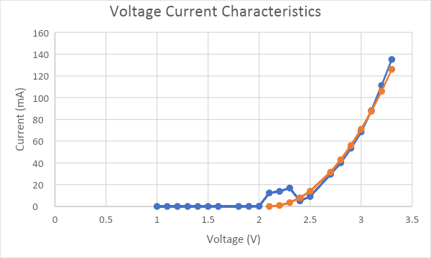

Figure 4: Voltage Current Characteristic

$$v_{ov}=v_{gs}-V_{t}, i_{D}=\frac{K}{2}v_{ov}^{2} K=\frac{2i_{D}}{v_{ov}^{2}}$$

Threshold Voltage can be found by inspection of our data at 2.1v

From there Vov = Vgs – Vt

Thus $i_{D}=\frac{K}{2}{(v_{GS}-2.1)}^{2}$

K = 175 mA/v^2 for every volt over 2.1v

**Step 12:**

**Step 13:** How do modeled results, defined in Eq. 1 compare to simulated and hardware behavior?

The modeled results defined in equation 1 compare to the simulated and hardware because the gain of the current in the saturated region slowly increases with higher voltage at about the same rate as modeled by equation 1.

**Step 14:** What is the average transconductance (gm) of the 2N7000 transistor, i.e. how does ID change with vGS for large values of vDS (i.e. in the active region)?

$$g_{m}=\frac{∆i_{D}}{∆v_{GS}} in \frac{A}{V} for \left|v_{DS}\right|≥2V$$

$$g_{m}= \frac{(0.4-0.16)}{(1.5-1)}=48mA$$

**3.3 MOSFET Switching Circuit**

**Step 1:** Which region of operation, triode or saturation, is ideal for use of the MOSFET as a switch? Why?

The triode region is ideal for use of the MOSFET as a switch since you would be increasing the supply voltage which would cause the LED to get brighter since the current across resistor and transistor increases.

**Step 2:** Design an LED switching circuit in PSpice using the 2N7000 transistor. An example is provided below.

**Step 3:** In the lab report, include a screenshot of YOUR PSpice schematic.

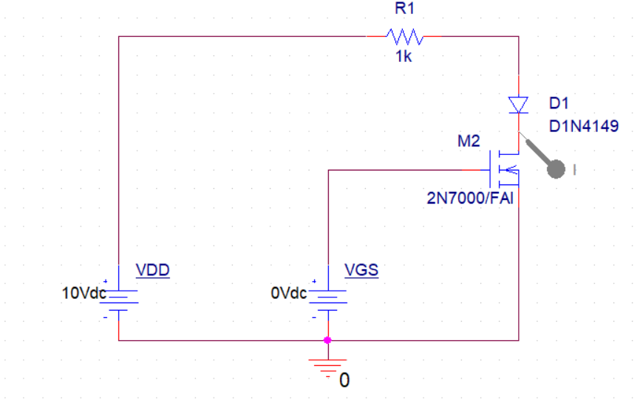

Figure 5: LED switching circuit in PSpice using the 2N7000 transistor.

**Step 4:** Illustrate the operation of the switch via dc sweep-type simulation of vGS.

**Step 5:** In the lab report, include an $i_{D}$ vs. $v_{GS}$ graph. Clearly label the graph when the LED “turns on” if one assumes that it requires 3mA of current for this. Please graph all simulation data in Microsoft Excel. Why does the $i_{D}$ vs. $v_{GS}$ trace reach a limit at about 9.3 mA?

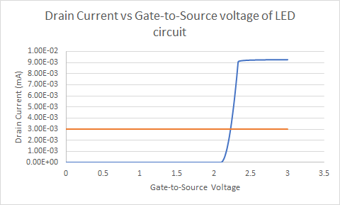

Figure 6: $i_{D} vs. v_{GS}$ graph

the trace reaches a limit at about 9.3mA since the circuit get saturated at about 9.3mA

**Step 6:** Build the circuit shown in Figure 14 using 2N7000 MOSFET, 1kΩ resistor, and LT03XX-41 red LED. Apply a supply voltage of 10 V. Apply a gate-source voltage (vGS) with the sine-wave generator where frequency = 1 Hz, Ampl = 1.5 Vp (3.0 Vpp), and Offset = 1.5 V. Refer to figures below.

**Step 7:** In the report, include a picture of your hardware.

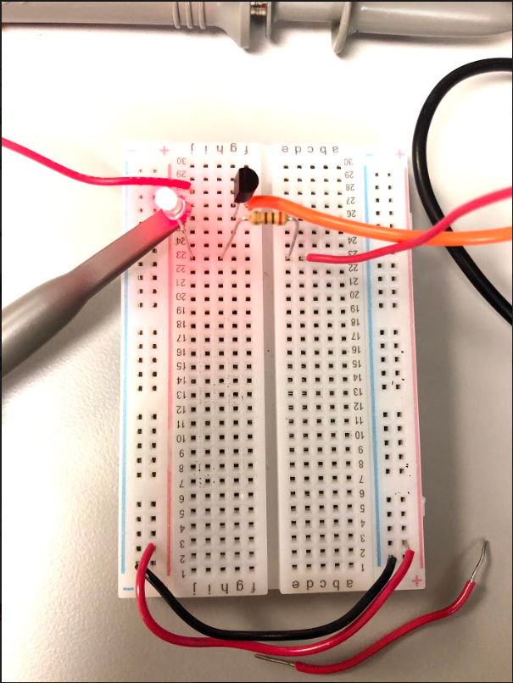

Figure 7: Picture of hardware when LED is lit

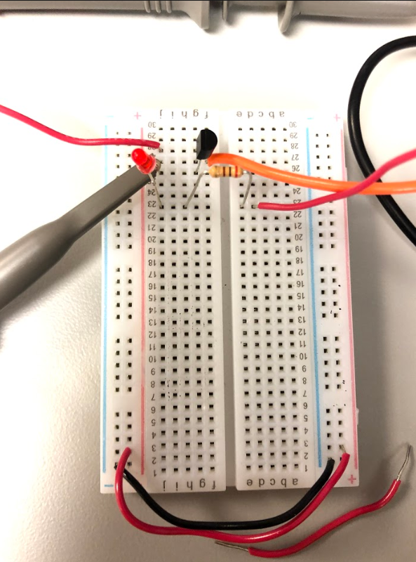

Figure 8: Picture of hardware when LED is not lit

**Step 8:** What is the switching threshold value of vGS? In other words, roughly what value of vGS causes the LED to turn on / off?

The threshold voltage is 1.7 V.

**Step 9:** Once appropriate voltages are supplied to the circuit, measure both $v_{GS}$ and $v_{DS}$ using the oscilloscope. Export this data from VirtualBench. Store and graph it via Microsoft Excel. Include all waveforms as a single graph in the report. Indicate the vertical and horizontal grid values and label the axes and the plot. Provide an informative caption.

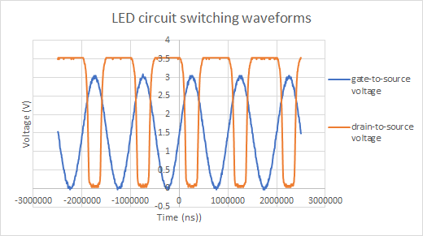

Figure 9: LED circuit Switching Waveform V vs. Time

**Step 10:** What is the LED doing (when all supplies are on)? How would one describe its physical appearance?

The LED was quickly flashing on and off.

**Step 11:** In fewer than 10 words, describe how a novice would use this circuit to turn an LED on and off.

Voltage greater than 1.7 V, LED turns on; otherwise, LED off.

**3.4 MOSFET Voltage Amplifier**

**Step 1:** Design a voltage amplifier in PSpice using the 2N7000 MOSFET and RD = 200Ω. Supply the circuit a 1000 Hz sine-wave input with an amplitude of 50mV and offset of about 2.5 V, as well as 6 V supply

**Step 2:** In the lab report, include a screenshot of YOUR PSpice schematic.

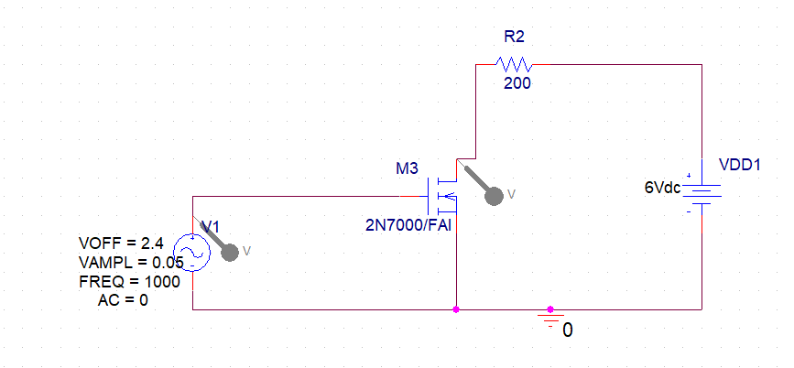

Figure 10: PSpice Schematic of the voltage amplifier

**Step 3:** Simulate the transient behavior of this circuit to 3ms (approximately 3 cycles). Use a maximum step size of 0.01ms.

**Step 4:** In the lab report, include a graph that compares the simulated input and output of your amplifier below. Please graph all simulation data in Microsoft Excel. An example is provided below.

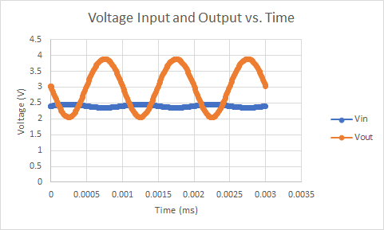

Figure 11: Voltage Input and Output vs. Time graph for voltage amplifier.

**Step 5:** What is the gain for this simulated amplifier shown in Figure 17? Provide answers in V/V as well as dB.

Gain is approximately 18.5 V/V, or 25.3 dB.

**Step 6:** Build the circuit shown in using 2N7000 MOSFET and 200Ω resistor. Apply a supply voltage (vDD) of 6 V. Supply an input voltage to the gate-source terminal (vGS) via waveform generator with frequency = 1000 Hz, ampl = 50.0 mV, and offset (starting point) = 2.5 V.

**Step 7:** In the report, include a picture of this hardware

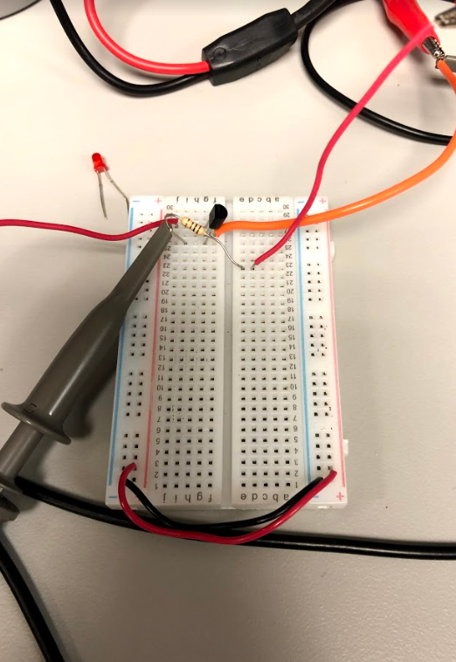

Figure 12: Hardware of the circuit of MOSFET Voltage Amplifier

**Step 8:** Once appropriate voltages are supplied to the circuit, measure both amplifier input (vGS) and output (vDS) using the oscilloscope. Export this data from VirtualBench. Store and graph it via Microsoft Excel. Include all waveforms as a single graph in the report.

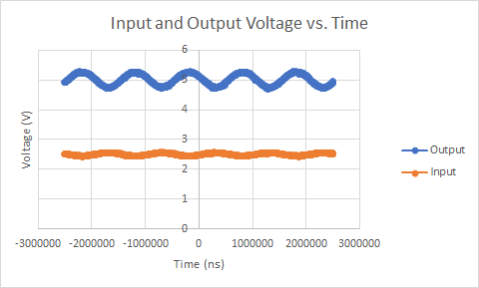

Figure 13: Input and Output Voltage vs. Time for voltage amplifier with new settings.

**Step 9:** What is the gain for the amplifier in hardware? Provide answers in V/V as well as dB.

Gain is 5 V/V or 13.98 dB.

**Step 10:** How do the simulated and hardware gains compare to one another?

The simulated gain was much higher than the hardware gain.

**Step 11:** Is the amplifier in the “saturation” region of operation here? Why, why not? Is this required for proper amp operation?

In this state the amplifier is saturated, as the gate voltage of 2.5v-2.6v is saturated with a source voltage of 0.5v where here we’re supplied with 6v.

**3.5 MOSFET Logic Gate Extra Credit**

**Step 1:** Design any digital logic gate (OR, AND, NOR, etc...) using the 2N7000 MOSFET. Students should include the following results in their report.

* Screenshot of circuit in PSpice.

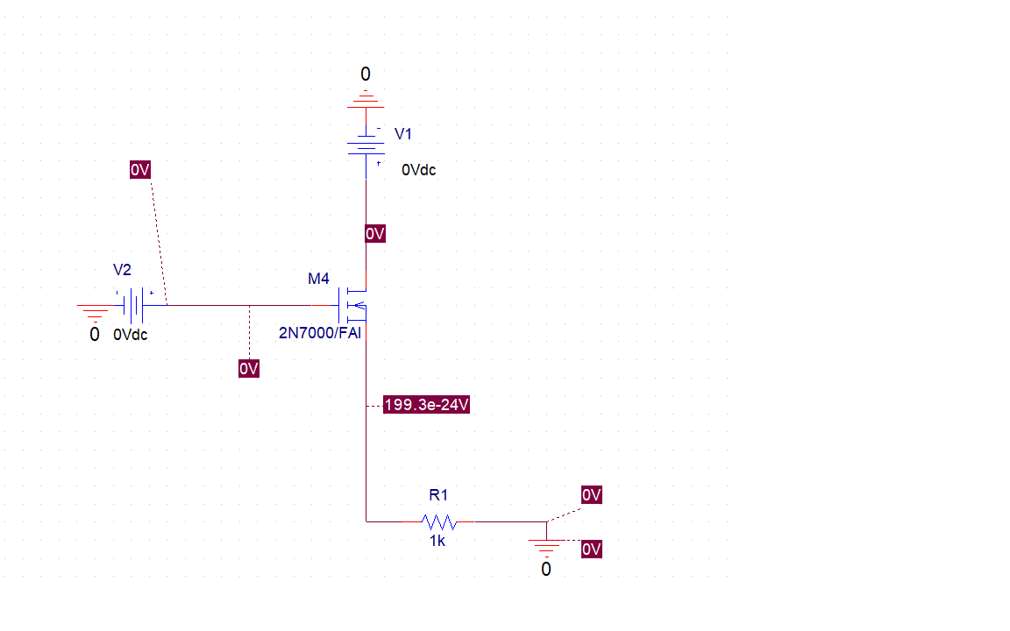

Figure 14: PSpice AND Gate with input 00.

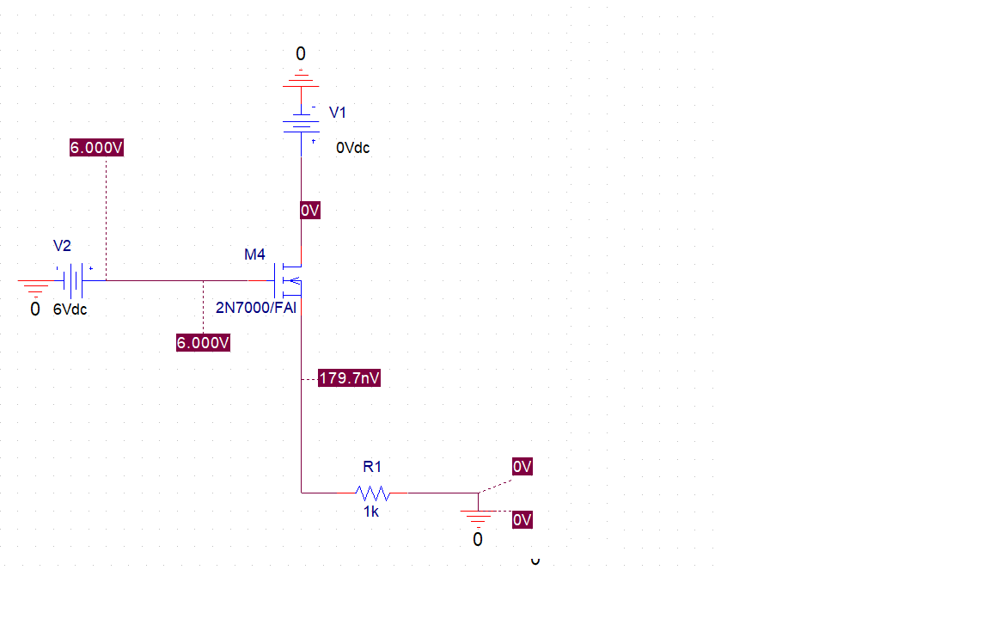

Figure 15: PSpice AND Gate with input 01.

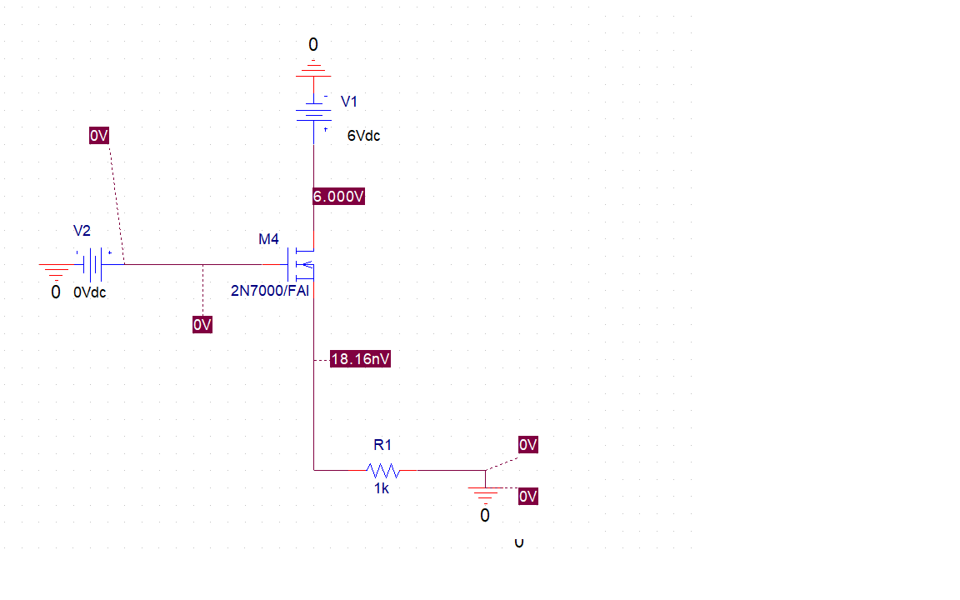

Figure 16: PSpice AND Gate with input 10.

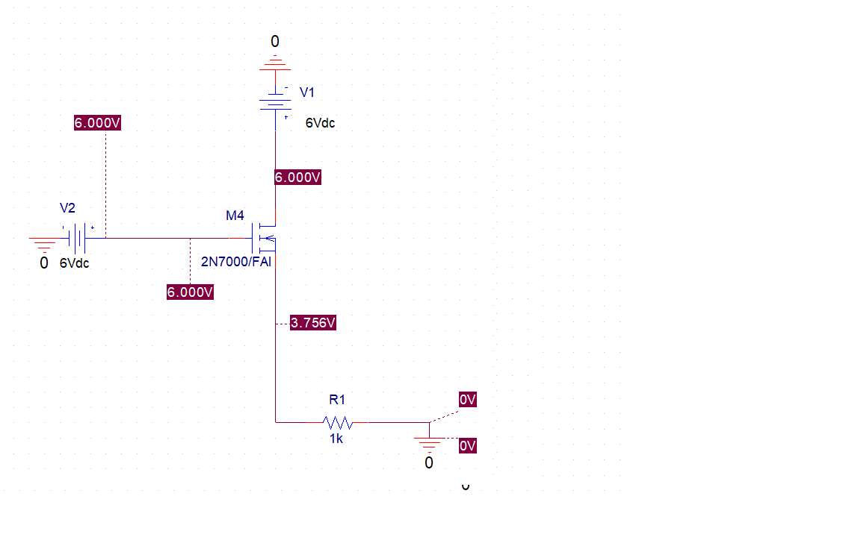

Figure 17: PSpice AND Gate with input 11.

* Photo of circuit in hardware.

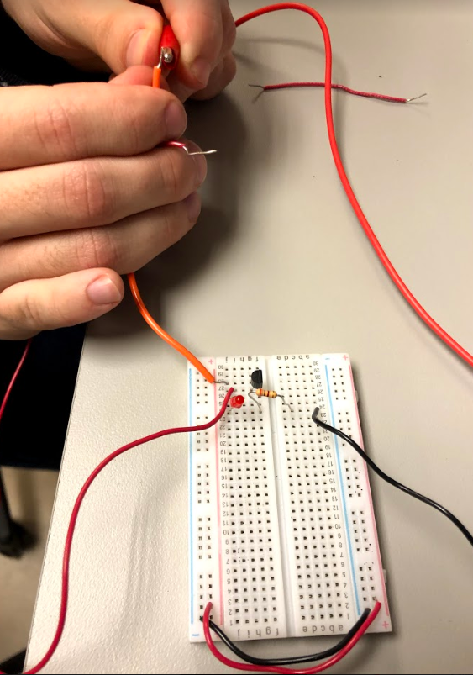

Figure 18: Hardware of only one voltage input

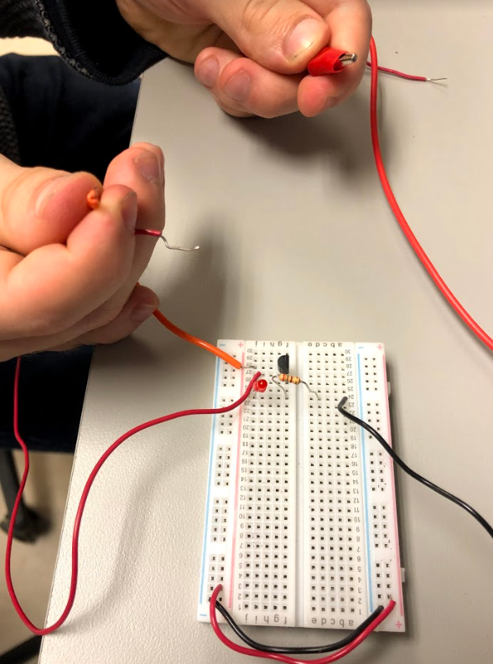

Figure 19: Hardware of no voltage input

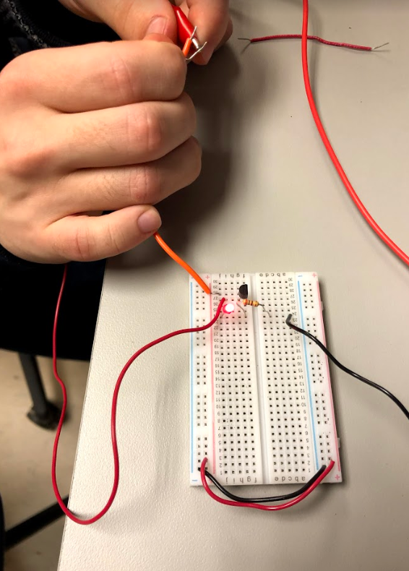

Figure 20: Hardware of both voltage input

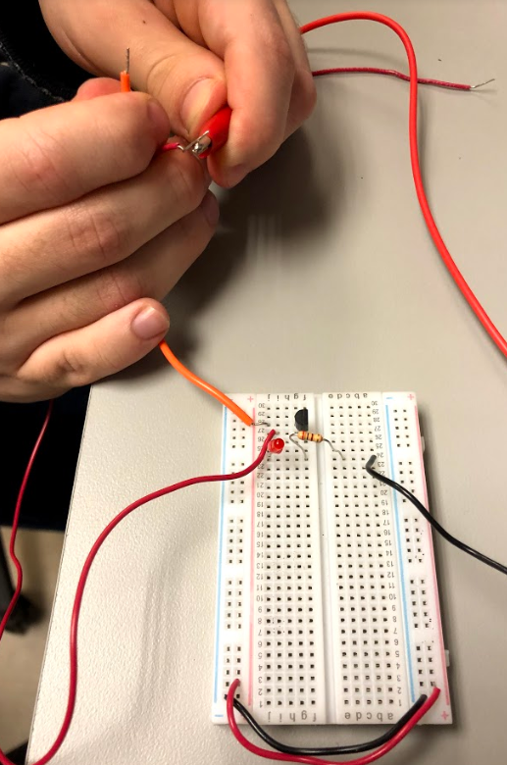

Figure 21: Hardware of other voltage input different from figure 18

* Table or graph demonstrating the performance of this logic gate.

|  |  |
| --- | --- |
| Input | Output |
| 00 | 0 |
| 01 | 0 |
| 10 | 0 |
| 11 | 1 |

Table 3: Truth table for an AND gate.

* Discussion of how the simulated and observed behavior compares to ideal.

Both the simulated and the observed behaviors had the correct corresponding outputs for every input.

**4. Conclusion (MF, AB)**

**4.1 Background Research**

In order to complete the lab, students would need to research 2N7000 MOSFET by downloading the device datasheet. The students would also need to read Microelectronic circuits chapter 5 to know the difference between triode and saturation regions of operation. In the students’ eyes, the objective of the lab is understanding how to use MOSFET by experimenting with hardware and PSpice different circuits.

**4.2 Procedure**

To complete this lab, students would need to test the characterization of a MOSFET using PSpice by designing a circuit. The next thing was using hardware to learn the characterization of the device by using a MOSFET and Virtual Bench. Once the students learned the characterization of a MOSFET then the students would need to create a circuit which uses the MOSFET as a switch by using LED to switch from on to off. Then by using PSpice and hardware the student would create a MOSFET Voltage Amplifier by using a sine-wave input. Some problems that students may encounter were using the virtual bench in order to create a waveform generator. To fix the problem students may use another device to provide the frequency and amplitude to the hardware which could be easier. The most interesting step in the lab was the extra credit section since students would need to create a MOSFET Logic Gate.

**4.3 Analysis and Results**

In general, this lab generated viable results, or at least results that were somewhat close to what was expected. Two cases where this did not happen were Table 1 and Part 4, Step 10. In Table 1, the data did follow the general trend of increasing steadily, but our values were not that close to the ones on the lab sheet. In Part 4, Step 10 our calculated and measured gains were decently different. However, for the rest of the lab there is only equipment error and noise skewing the data a little bit. This was good, as most of the graphs and tables almost matched between simulation and hardware. The most interesting observation from the data was during Part 3 when the switch circuit was created with the MOSFET. It was cool to be able to find a voltage value that made the LED constantly turn on and off.

**4.4 Closing Ideas**

One big lesson that was taken away from this experiment was the various uses of a MOSFET. Just in this lab multiple different applications of MOSFETS were tested and implemented. Another lesson from this experiment is how saturation can affect your circuit. Multiple parts in this lab demonstrated saturation coming into play. This experiment will help students excel in future classes and in lecture by demonstrating and reinforcing concepts that we have learned about previously. The most enjoyable part of this activity was trying to design the AND gate circuit for Part 5. It was very interesting to try and come up with the circuit for that part. One thing that I would propose should be done differently is that the explanations for constructing the calculated vs. measured graphs should be more elaborate and explicative.

**5. References: (JB)**

* Microelectronics Circuits by Sedra and Smith; OxfordUniversity Press; Latest Edition
* Applications of FETs <http://www.circuitstoday.com/fet-applications>
* Theory and application of the field-effect Cobbold and Trofimenkoff <https://ieeexplore.ieee.org/stamp/stamp.jsp?arnumber=5247986>